**WEB ENGINEERING Course Instructor: Razi Ahmed Date: 15-12-2017 LAB 09 HTML, CSS, JavaScript**

**Note:**

* Student collaboration is not allowed.
* Copying from or looking at solutions from other sources is strictly prohibited.
* Violations will not be excused and may result in an F in the course.
* Stay honest.

**TASK # 1**

Design the following Sign up page of Yahoo.

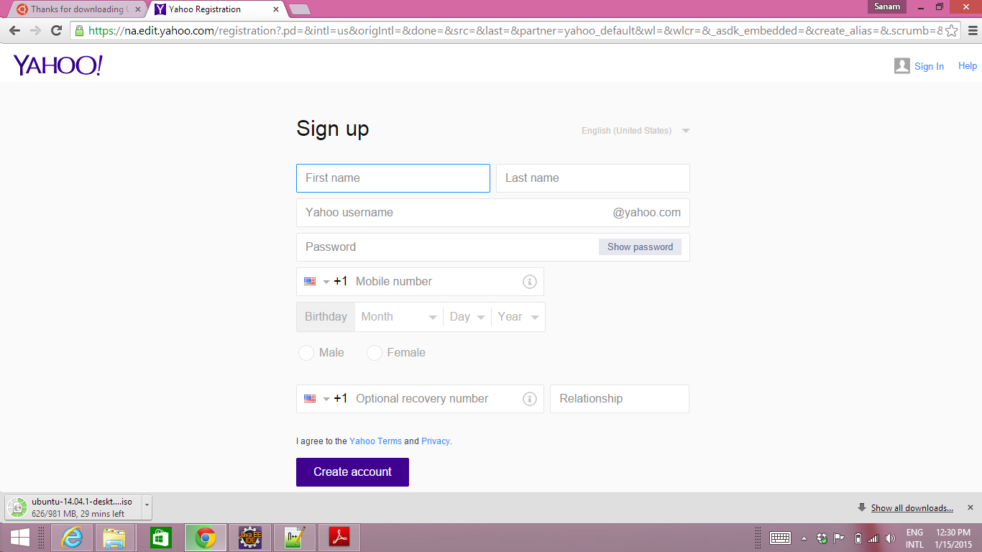

**TASK # 2:**

Design a simple HTML Page that contains three input text fields and two buttons. If a user enters a string and clicks on a button named as “**Find Number of Words (Space Separated)** “then the result should be shown in **Result** text field as shown in the diagram given below. Similarly if a user clicks on a button named as “**Find Word in String**”, if a word exists in the input string it should show a pop-up message with “**Found**” else “**Not Found**”. Use JavaScript.

a)

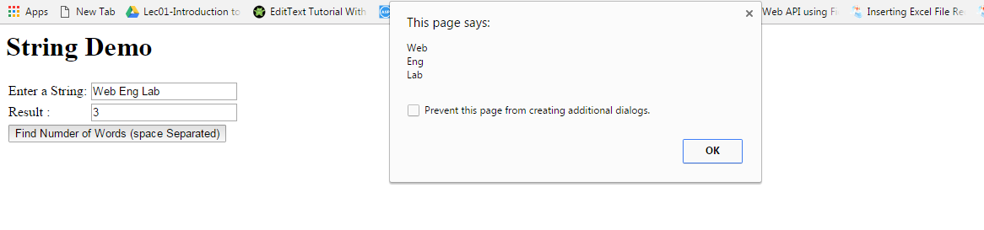

b)

